**Texture Atlas Creator**

**Binyamin Brion**

**March 15, 2020**

**Table of Contents**

Contents

Introduction 3

What is a texture atlas? 3

Why use a texture atlas? 3

What is Texture Atlas Creator? 4

Features: 4

Using the Texture Atlas Creator 5

Program Layout 5

Creating a Project 6

Loading a Texture 6

Populating the Atlas 7

Editing the Atlas 8

Editing a Texture 9

Viewing Texture Information 10

Exporting the Atlas 11

Saving a Project 12

Opening a Project 13

# Introduction

## What is a texture atlas?

## 

## A texture is any image. This can be a photo taken or a picture created by an artist. Most of the time, an image is just that- a single picture. But it does not have to be. It possible that within an image, there exists multiple images. For example as in Figure 1:

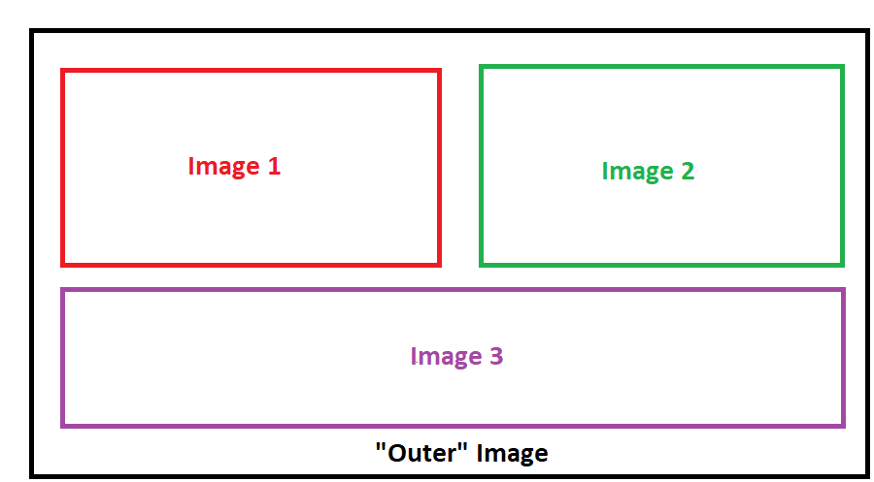

**Figure 1: An example layout of a texture atlas**

In Figure 1, there is an outer image- this is the overall image, the file that is seen in a file explorer. Once opened in a image viewing program, the three other images- Image 1, Image 2, Image 3- would be seen. This packing of images within another image is a texture atlas.

## Why use a texture atlas?

Depending on what the texture atlas is being used for, it can be more efficient to use a texture atlas than the images contained within the atlas separately. When using a texture atlas, all of the images contained within can be treated as a single entity by the Graphics Processing Unit (GPU), which involves less context switches. This in turn improves performance.

The primary issue using texture atlases involves mipmapping. In graphics rendering, the further an object using a texture is away from the player’s position, the more a lower resolution of the original texture is used. See Figure 2:

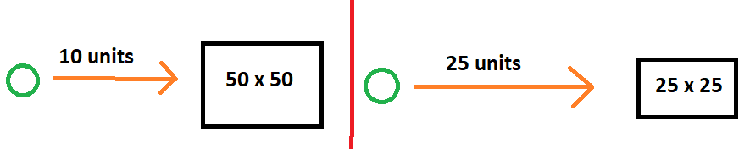

**Figure 2: Situation involving mipmapping**

Figure 2 demonstrates a scenario in which an object using a texture (black box) is a certain distance from the user (green circle). On the left, a texture with a resolution of 50 x 50 is used. However, as the user moves away from the object as seen on the right, the resolution of the texture used becomes smaller: 25 x 25. Since an object looks smaller the farther it is away from the user, this decrease in resolution is not noticeable, and it improves performance.

These lower resolutions of the original texture can be generated by successfully halving the resolution of a texture. When this happens, the distance between adjacent images within an atlas also halves. This can continue until there is no distance between adjacent textures. Due to finite precision in specifying what part of an atlas to use, adjacent textures can “bleed” into a texture within the atlas along its borders. This be averted by specifying large enough distances between adjacent images, so that even after mipmapping, adjacent images still have a large enough distance between them.

## What is Texture Atlas Creator?

A program to help in creating atlases. It allows users to merge images into one texture, hence creating an atlas, while also letting the distances between images to be set and enforced. Additionally present is the ability to modify the texture in place with simple paint operations, and to create and modify a specular texture for the given image.

## Features:

* Create atlases of arbitrary sizes and many difference image formats
* Ability to set distance between textures and enforce them
* Move textures around to optimize available space
* Apply simple edits (and undo them) to both the texture themselves and associated specular textures
* Save the project to reopen it later for future work, which will also save a copy of the textures themselves and specular textures
* View information about the textures in the atlas

# Using the Texture Atlas Creator

## Program Layout

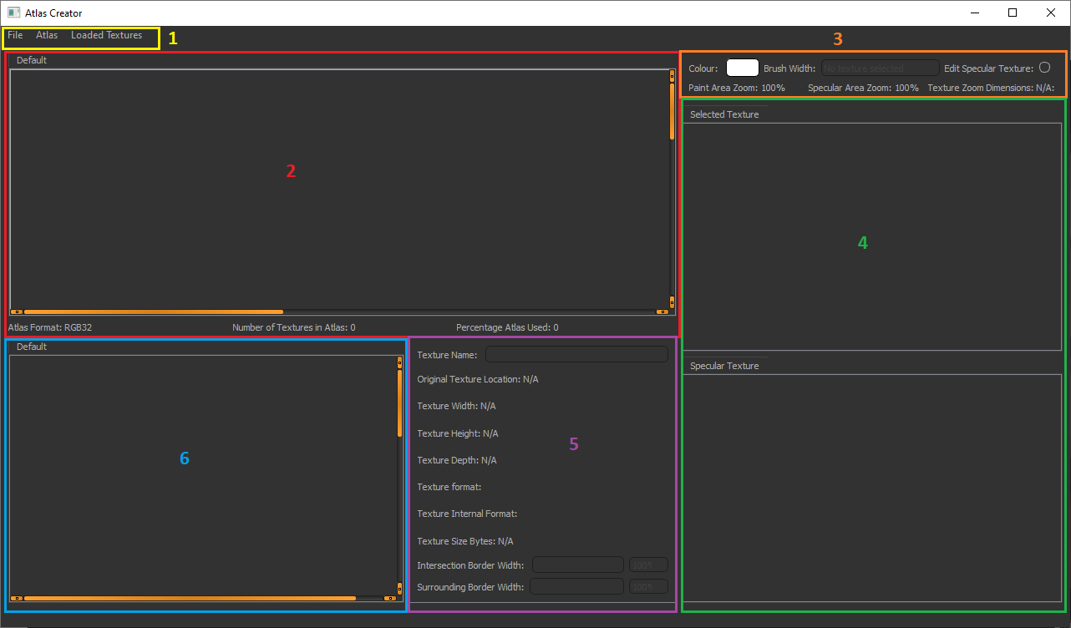 Upon launching the program, the following is seen:

**Figure 3: Layout of the program**

The areas within the program are as follows:

1. Menu bar. Contains the actions to start working on an atlas.
2. The texture atlases being worked on. The text below the scroll area displays information about the currently viewed atlas.
3. Modify the brush used for painting when a texture within the atlas is selected.
4. Paint area and a display area for the specular texture display.
5. Area that displays information about the currently selected texture
6. Displays loaded textures into the program that can be placed into an atlas.

To get a feel of how to use this program, a walk-through of creating a sample texture atlas will be shown.

## Creating a Project

By default, when the program is opened it will have an empty project created. Work can be started from this empty project. Otherwise, the following steps can be used to create a new project:

* Click on ‘File’ in the menu bar *
* Click on ‘New Project’ *
* If the currently opened project has an unsaved changes, a pop-up will appear asking if changes should be saved. Either specify do not save the changes, or proceed to save them
* A new empty project will be created

* These steps can be replaced by using the keyboard shortcut ‘Control + N’

## Loading a Texture

When a texture is loaded, it is stored in a “texture area” (Area 6 in the Figure 3). This is a tab that contains buttons that when clicked, will load the texture they represent into the currently viewed atlas. To add, rename or delete a texture area, either right click the tab or specify the desired action in the ‘Loaded Texture’ menu.

To load a texture, go to:

* In the menu bar, click ‘Loaded Textures’
* Click on ‘Load Texture’

Or alternatively, press ‘Control + L’.

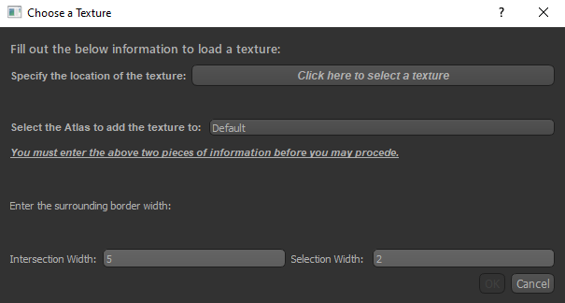The following pop-up will appear:

**Figure 4: Pop-up when loading a texture into the program**

First, choose the location of a texture using the respective load texture button. Afterwards, the tab where to load the texture has to be specified. Right now, there is only one tab that can be chosen, so this is left as is. Then, the intersection width of the texture- the minimum distance between this texture and adjacent textures- and the selection width- the visual border a texture has when it is selected- have to be specified. With these pieces of information, click ‘Ok’. (Until valid information is present, the ‘Ok’ button will not be available)

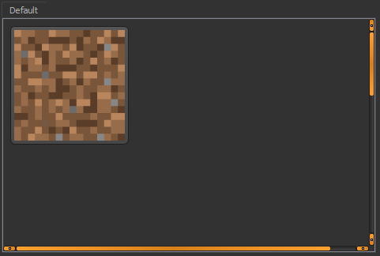After specifying the above information, the texture area tab specified will have a button representing the loaded texture, as seen in the below figure:

## **Figure 5: A loaded texture**

Thing to note are:

* A texture can be loaded into the program once. As a result, a texture button representing a loaded texture can be present in only one texture button at a time.

## Populating the Atlas

Like the texture button area, each atlas lives within its own tab (Area 2 in Figure 3). Adding a new atlas can be done by right-clicking any atlas tab, or specifying the desired action in the ‘Atlas’ menu.

To add a texture to the atlas, open the atlas by opening its tab. Then, click a texture button in any of the texture button areas. With that done, move the cursor over the atlas.

When a suitable position for the texture within the atlas is found, left click to place it there. If placing a texture would cause an intersection between another atlas (due to the intersection border), then a red outline will appear around the selected texture and an existing texture in the atlas. Such an example is seen in Figure 6 (note that the intersection border width was increased for the selected texture to make the red outline more visible).

## 

**Figure 6: An example of intersection between textures**

## When an intersection occurred, the selected texture cannot be placed until a new position with no intersection is found. Things to note:

* If the texture cannot be viewed entirely within the atlas due to the zoom of the atlas, then it is required to zoom out
* To cancel the placement of an atlas, press the ‘Escape’ button
* An atlas cannot contain the same texture more than once

## Editing the Atlas

To move a texture within the atlas, left a texture and with the left-mouse button down, starting dragging the texture. The same restrictions for texture placement when adding at texture to the atlas- an intersection between the selected texture and another texture- exist. To deselect a texture, left-click the texture again.

While a texture is selected it will have an orange outline around it. See Figure 7 for an example of this scenario.

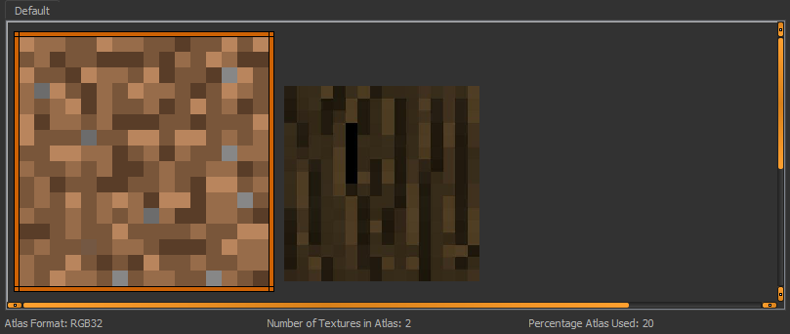

**Figure 7: An example of a selected texture**

## Editing a Texture

To edit a texture, navigate it to an atlas where it was placed and select it. When that is done, area 3 and 4 in Figure 3 will change to allow editing of the texture. This situation is seen in Figure 8:

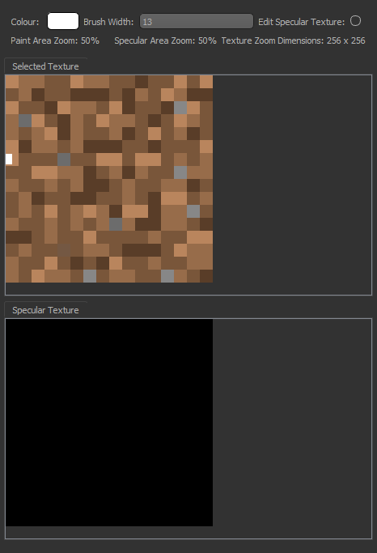

## **Figure 8: A selected texture can be modified**

With a texture selected, it can now be modified. The area directly below the brush settings- where the texture is displayed- is called the paint area and can be used to modify the texture itself and the associated specular texture. The area below- that contains the black rectangle- is the specular texture for the selected image. It is all black as that is the default specular texture, and no modifications have been made.

To modify the texture itself, make sure that the radio button ‘Edit Specular Texture’ is turned off. Then, select a colour brush by pressing the colour button and choose a brush width. With that done, simply left-click and drag across the paint area to start painting the texture.

To edit the specular texture, make sure the radio button ‘Edit Specular Texture’ is switched to on. The colour brush chosen must be a grey-scale value; if the chosen colour is not, then the colour chosen will be averaged out to a grey-scale value. For example, if the colour (255, 0, 0) is chosen, which is red, then the averaged colour will be (85, 85, 85). Start painting in the paint area, but notice that instead of changes being applied to the texture, the changes are applied to the specular display area.

Here is an example of what the above texture looks like after some changes:

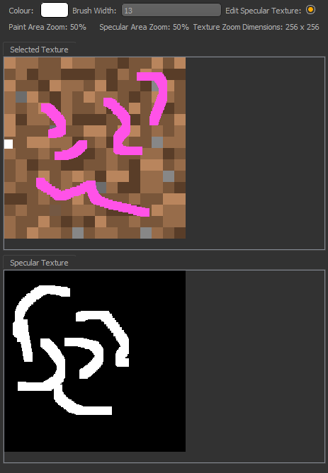

**Figure 9: Modified selected texture and modified associated specular texture**

Things to note:

* As changes are made to the texture (not the specular texture) all changes will be reflected in atlases that have the selected texture, as well as the texture buttons that represent the selected texture
* The brush width must be a positive value not greater than the smallest of the texture’s width or height at a given paint area zoom value. For example, at 100% zoom a texture’s width may be 100, height is 50. The max brush width is 50. At 200%, the texture’s width is 200 and the height is 100. The max brush width is 100.
* The paint area and the specular display area can have its zoom changed by moving the cursor over the respective area holding the control key and scrolling. Note that after each zoom change the control key has to be clicked again
* If the zoom changes, it’s possible while editing the specular texture that changes are not appearing. Make sure you are looking at the correct part of the specular texture, where the changes are being made. Due to zoom, those areas may not be in view
* All changes can be reverted by using ‘Control + Z’

## Viewing Texture Information

With a texture in an atlas selected, area 5 in Figure 3 display information about the selected texture. For example:

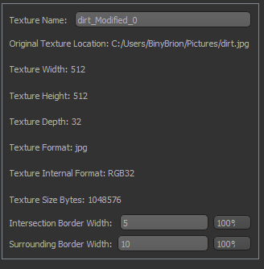

## **Figure 10: Various information about the texture**

The information shown is about both the texture itself- as seen on the file system- and the information in the program. It is here the intersection border width and selection border width of the selected texture can be changed. When these border widths are changed, they are specified at the zoom level shown. At higher zoom levels, large numbers are specified, due to how zoom works. For example, a border width of 10 at 100% zoom is the same as 20 at 200% or 5 at 50%.

## Exporting the Atlas

To export an atlas, make sure it is opened by clicking its tab. Then either:

* Click on ‘File’ in the menu bar
* Click on ‘Export Current Atlas’

Or

* Enter the keyboard shortcut ‘Control + E’

A file dialog will appear asking where to save the atlas. Specify a name and click save. The exported content will be the atlas with the textures, and the atlas of the associated textures as well. The exported atlases are saved in png format to ensure no loss of quality.

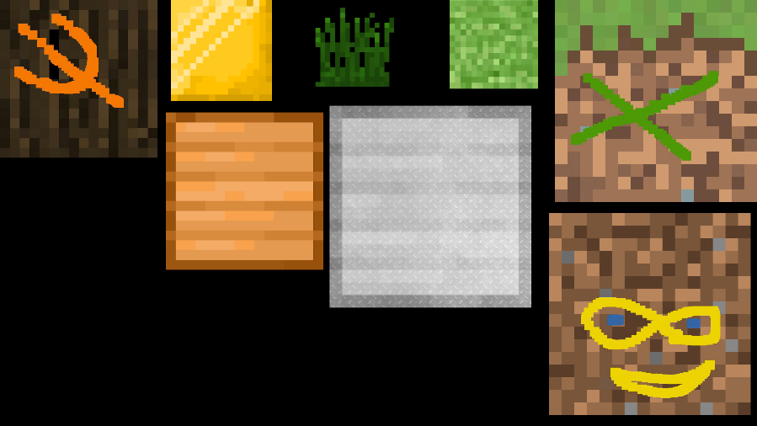Below is a sample of an atlas that was exported along with the associated specular texture atlas:

## 

## 

## 

## **Figure 11: A sample export result**

## Saving a Project

A project can be saved for future work. To save a project, either:

* Click on ‘File’ in the menu bar
* Click on ‘Save’ to save an existing project
* Click on ‘Save as’ to save a new copy of the existing project

Or

* Enter the keyboard shortcut ‘Control + S’

In both cases, ensure that the saved location will not overwrite existing files, as overwriting may fail depending on the permissions granted to the program.

The save project will be a directory holding all of the textures loaded into the program and all of the associated specular textures. In addition, there will a *projectName*.tac file that describes the structure of the project. Do NOT modify these saved contents.

## Opening a Project

To open an existing project, the following steps need to be done:

* Click on ‘File’ in the menu bar *
* Clock on ‘New Project’ *
* If the currently opened project has an unsaved changes, a pop-up will appear asking if changes should be saved. Either specify do not save the changes, or proceed to save them
* A file selector dialog will appear. Navigate to the folder where the project was saved and select the *projectName*.tac file
* The saved project will be opened

* These steps can be replaced by using the keyboard shortcut ‘Control + O’